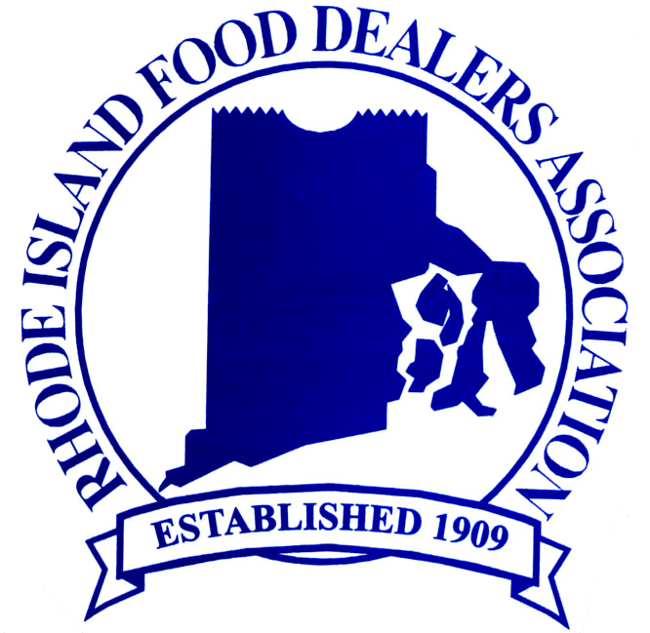

July National Legislative Update on Key Issues
And Opportunities
Supreme Court Issues Health Care Decision, Upholds Individual Mandate:
The Supreme Court issued its long awaited ruling on the Patient Protection and Affordable Care Act (P.L. 111-148), largely upholding the law in its entirety and preserving the law’s main provision: the individual mandate. The vote was 5-4. Chief Justice John Roberts sided with Justices Ginsberg, Breyer, Sotomayor and Kagan to consider the requirement for individuals to purchase health insurance (aka the individual mandate) as a tax, which is within Congress’ Constitutional power. In their dissenting minority opinion, Justices Kennedy, Scalia, Thomas and Alito wrote that the health care law should have been struck down in its entirety. Writing for the Court’s majority opinion, Chief Justice Roberts argued that Congress does not have the authority to impose the individual mandate under the Commerce Clause, making a distinction between regulating commerce and compelling it. However, Congress does have the authority to “lay and collect taxes,” and Roberts argues that the mandate’s penalty must be construed as a tax on those without insurance. The Court struck down one part of the law that would have expelled states from Medicaid if the states opted out of the expanded eligibility for the federal-state health program. We have attached a copy of a summary of the decision and its impact written and provided by Washington Council Ernst & Young.
The Food Marketing Institute (FMI) issued a press release and FMI policy positions on several provisions of the health care law yesterday in response to the Court’s decision, expressing concern over the uncertainty over the still unreleased regulations and guidance documents with respect to employer coverage that the law requires to be in place by January 1, 2014. Specifically, FMI is seeking guidance with regard to the definition of a full-time vs. part-time employee as it applies to coverage requirements and that employer-offered plans pass both the affordability and minimal value requirements of the law. FMI is also focused on two of the law’s provisions that specifically impact supermarkets: menu labeling and the limitations of the use of FSA debit cards to purchase over-the-counter medicines. For additional detail on this legislation and its components with a calendar of scheduled events) please see “Affordable Care Act After Supreme Court Decision” available in the national legislative section of the RIFDA website.
Menu Labeling:
With the Supreme Court upholding the Affordable Care Act, including its chain restaurant menu labeling provision, FMI and other national lobbying groups are seeking House co-sponsors to fix the one-size-fits-all menu labeling law and regulations by codifying FDA’s Option 2 so the menu labeling regulations are not expanded to include mainstream grocery stores and to provide some compliance flexibility for restaurant delivery operations.
NYC Proposed Ban of Large Sweetened Beverages
New York City Mayor Bloomberg’s proposed beverage ban, which caps most sugar-sweetened beverages at 16 ounces and carries a $200 fine for vendors that do not comply, was officially submitted to the New York City Department of Health earlier this week. The proposed ban would not apply to diet sodas, fruit juices, dairy-based drinks like milkshakes, or alcoholic beverages. In addition, it would not extend to beverages sold in grocery or convenience stores, because they are regulated by the New York State Department of Agriculture. The NYC Board of Health now has 90 days to review the proposal and will be accepting comments and conducting hearings. The Board is made up of eleven members, all appointed by Mayor Bloomberg. To learn more about the proposal,
Senate Continues Work on Farm Bill; SNAP-Block Grant Amendment Defeated:
The Senate finished its second week of consideration of the Farm Bill as procedural entanglements leave the fate of final passage unresolved. An amendment by Senator Rand Paul (R-KY) to transform SNAP into a block grant program was also defeated by a65-33 vote and an amendment offered by Senator Jeanne Shaheen (D-NH) to phase out the federal sugar program was effectively defeated by a 50-46 vote.
Several amendments have been introduced but not scheduled for a vote, including amendments to:
· Impose nutritional standards on SNAP-eligible purchases, offered by Sen. DeMint (R-SC);
· Require USDA to conduct at least five state SNAP “pilot” programs outside of the federal program, offered by Sen. Wyden (D-OR);
· Restore $4.5 billion for the SNAP-LIHEAP exemption; add $500 million for the Fresh Fruit and Vegetable program; and allow USDA to make “bonus” purchases for food banks based on states’ market conditions, offered by Sen. Gillibrand (D-NY);
· Allow states to circumvent FDA’s existing authority on food labeling by allowing states to require labeling for any food, beverage, or other edible product that contains genetically engineered (GE) or modified (GM) ingredients, offered by Sens. Sanders (D-VT) and Boxer (D-CA). FMI is sending a letter up on Monday morning to the full Senate in opposition to this amendment. An advance copy is attached above.

