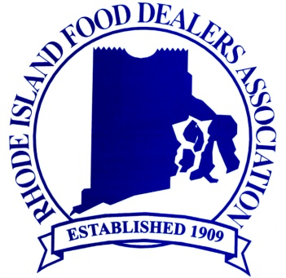
Member Focused; Results Driven
_____________________________________________________________________________________

FOR IMMEDIATE RELEASE Media Contact:
Lisa Wery
401-431-0880
lwery@rifda.com

RHODE ISLAND FOOD DEALERS ASSOCIATION TRADE DAY 2012

East Providence Rhode Island – March 13, 2012 -- The Rhode Island Food Dealers Association (RIFDA) hosted their Annual Trade Day on Thursday, March 8th, from 2:30PM to 9:00PM at the Providence Marriott Hotel. The program included an exciting and informative industry seminar, “Social Media & the Food Industry, What It Means to You.” The seminar was facilitated by James Spellos – a noted technology and communication consultant and President of Meeting U. The seminar was well attended and the participants were enthusiastic and very receptive to the information presented in the seminar.

The RIFDA Trade Day was also the setting for the state of RI Best Bagger Competition which chooses the Rhode Island representative to the NGA “National Best Bagger Contest” held annually during their convention and featured on the David Letterman Show on CBS. “The Best Bagger contest is an exciting, vibrant and fun-filled event where Rhode Island’s best grocery baggers can show off their speed and accuracy - and compete for a shot at the national competition”, said Steve Arthurs, President & CEO of the Rhode Island Food Dealers Association. Represented at the competition were Brigido's Fresh Market, Clements' Marketplace, Eastside Marketplace, Shaw's Supermarkets and Stop & Shop.

The evening also featured a unique networking opportunity at a reception featuring many legislators of the RI General Assembly who met with members of the Food Dealers. This was followed by our annual RIFDA Industry Awards Dinner. This year’s dinner featured the 2012 RI Food Industry Honoree of the Year Michael McQuade of McQuade’s Marketplace for his outstanding contributions to the food industry and to his community. Michael is a leading innovator in the area of sustainability of which he has received national recognition.

The day’s events proved to be both informative and entertaining and the association was excited with the level of interest members displayed. This event serves the food industry of RI well and provides a unique opportunity to network, learn, and celebrate its members in an exciting format.

###

About Rhode Island Food Dealer’s Association:
The RIFDA was established in 1909 and today represents over 300 food organizations throughout the state including independent and chain retailers, wholesalers, distributors, manufacturers, suppliers, brokers and other affiliates. Combined, the food industry in RI represents the largest source of revenue generators within the state and with one exception employs more people than other industries in the region.

The RI Food Dealers Association has and will continue to provide the services and functions needed that help its members successfully compete and grow by acting as a resource that understands their needs and provides them with information, education, representation as well as other effective programs. For more info visit www.rifda.com

RIFDA
~ Metacomet Executive Office Park ~ 450 Veterans Memorial Parkway, Bldg. 8 ~ East Providence, RI 02914-5300 ~
~ Tel: 401-431-0880 ~ Fax: 401-434-2496 ~ sarthurs@rifda.com ~ www.rifda.com ~

